Exp. No: 4
Measurement and Analysis of Dispersion Compensation in Optical Fiber using OptiSystem

OBJECTIVES
- To demonstrate dispersion compensation using the Ideal Dispersion Compensation component in OptiSystem.
- To observe the broadening of a 12.5 ps optical Gaussian pulse after propagation through 10 km of single-mode fiber (SMF).
- To compensate the accumulated dispersion of 160 ps/nm and verify recovery of the original pulse shape.

SOFTWARE REQUIRED
OptiSystem Software
CIRCUT DIAGRAM:
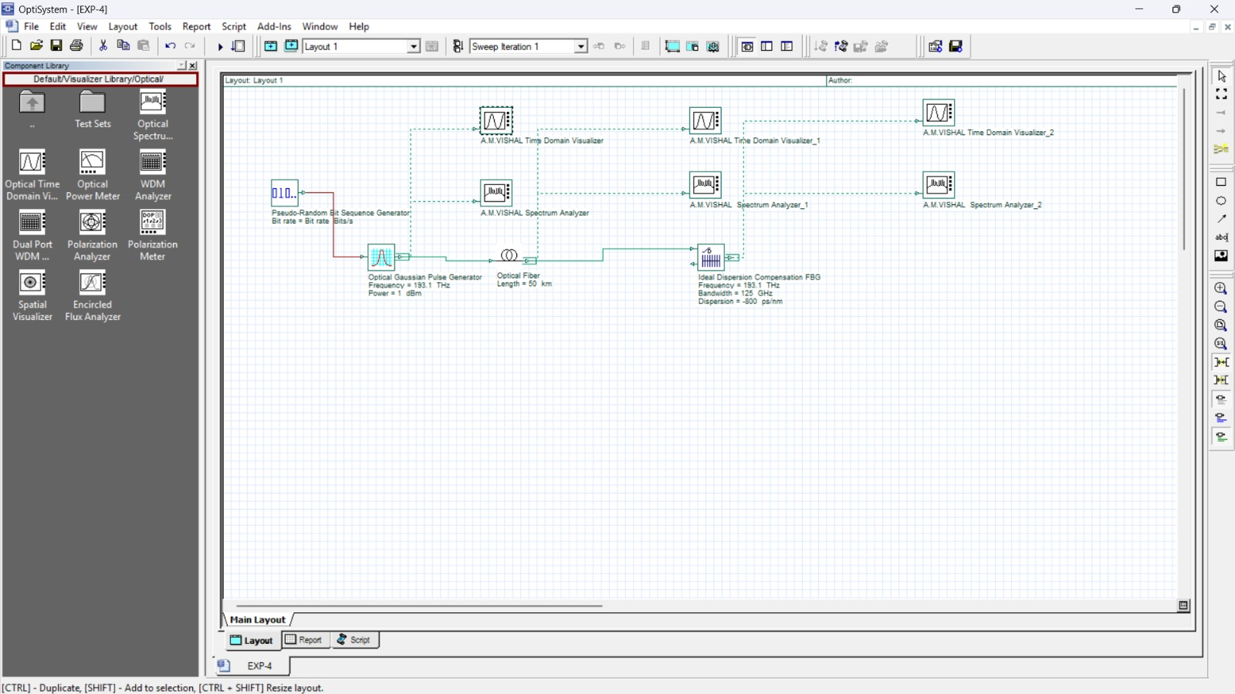

OUTPUT GRAPH:

Figure 1: Initial Gaussian pulse

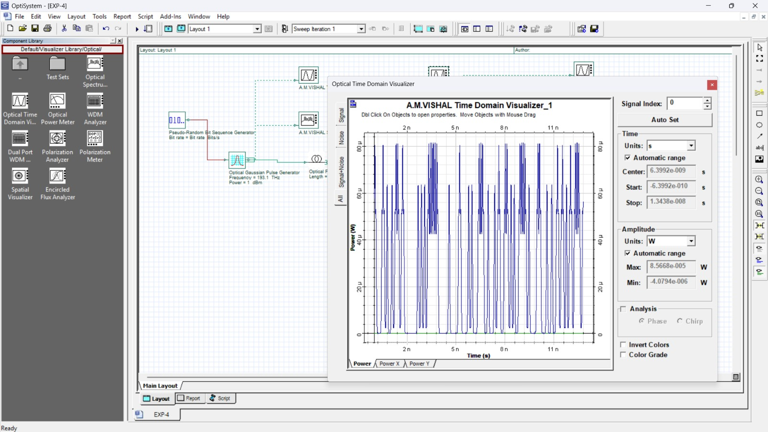
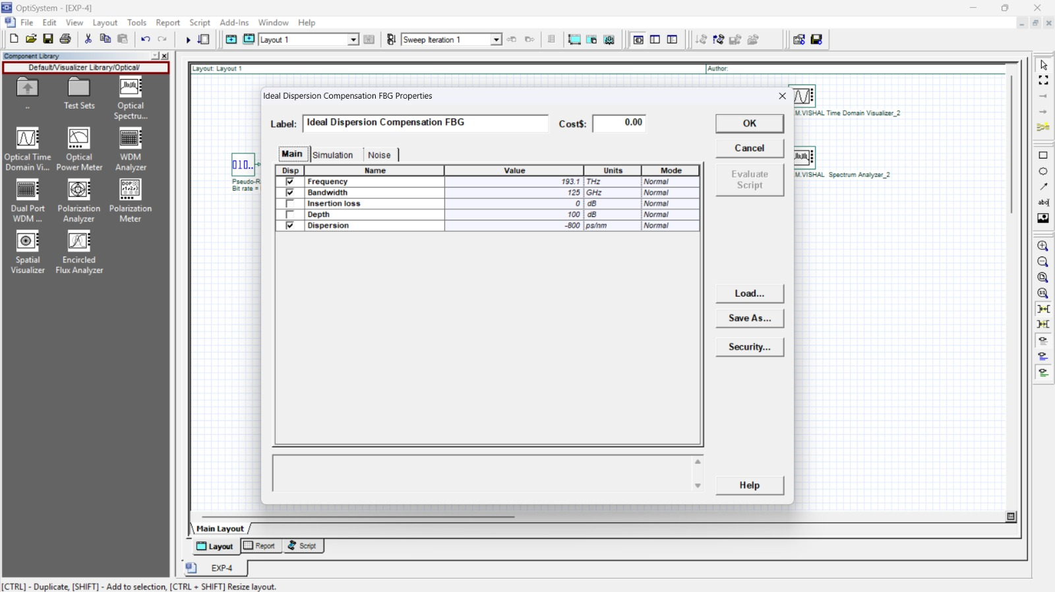
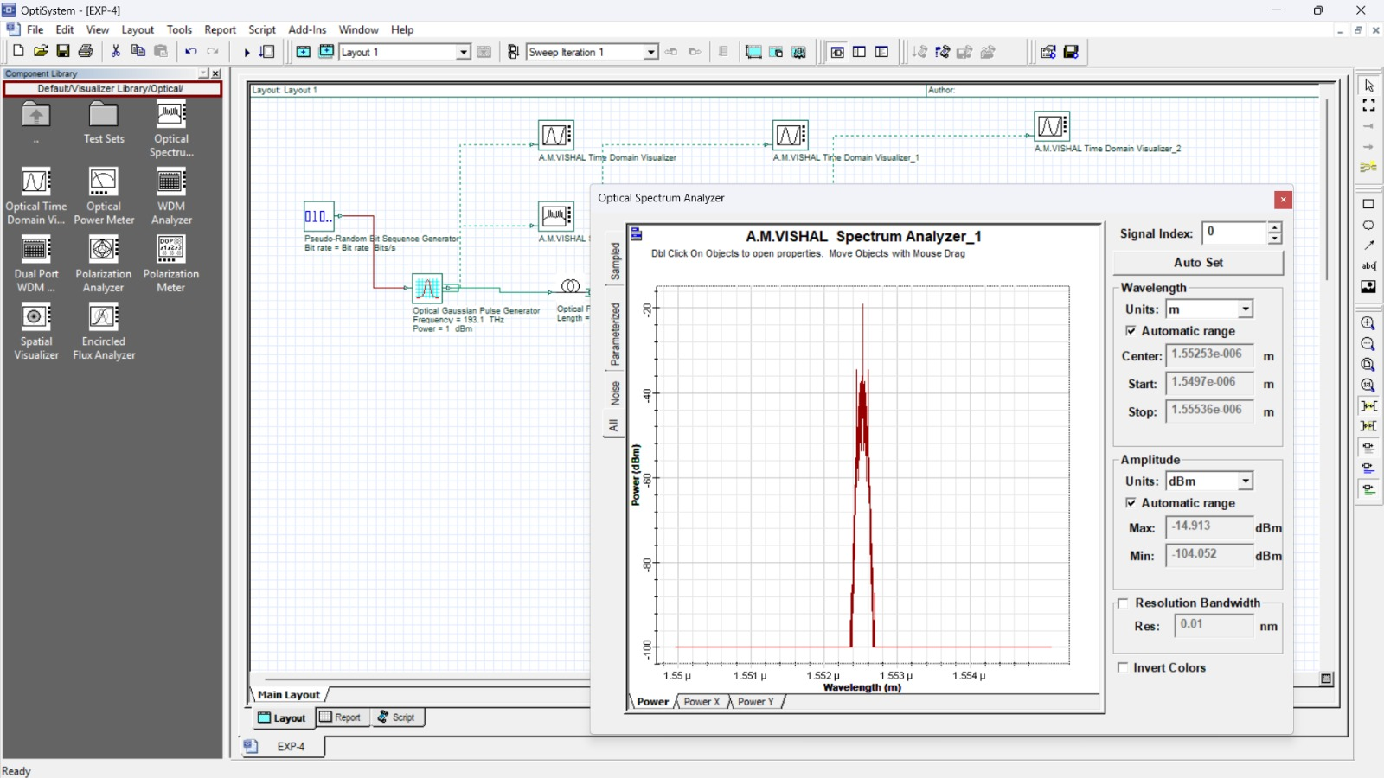

Figure 2: Gaussian pulse after 10 km propagation in SMF

Figure 3: Parameters of Ideal Dispersion Compensation component

Figure 4: Pulse after dispersion compensation with Ideal Dispersion Compensation component

OUTPUT PARAMETERS

Stage | Observation Point | Result | Figure
Initial pulse | Gaussian pulse generator output | Gaussian pulse, 12.5 ps | Figure 1
After propagation | Output of 10 km SMF | Pulse width increased ≈ 4 times | Figure 2
Compensator  setting | Ideal Dispersion  Compensation FBG | Dispersion = –160 ps/nm | Figure 3
After compensation | Compensator output | Original pulse recovered (exact compensation) | Figure 4

Reflection
I learned how dispersion causes pulse spreading in optical fibers. I understood how dispersion compensation helps improve the quality of the received signal.

LABORATORY PERFORMANCE ASSESSMENT RUBRIC

Objective | Assessment  Criterion | Excellent – 4 | Good – 3 | Satisfactory  – 2 | Needs  Improvement  – 1 | Weightage
Design the OptiSystem layout | Project layout | Builds the complete layout with correct components and connections independently | Minor connection errors corrected | Needs guidance for  components  or connections | Unable to build the layout | 20
Configure pulse, SMF and compensator parameters | Parameter configuration | Sets all parameters (40 Gb/s,  12.5 ps, 193.1 THz, 10 km,  –160 ps/nm, 125 GHz) correctly | Minor parameter errors | Needs guidance for several parameters | Unable to configure parameters | 20
Observe pulse broadening in  SMF | Pulse observation | Captures and interprets initial and broadened pulses correctly | Minor  interpretation errors | Limited observation / needs help | Unable to obtain or interpret pulses | 20
Verify compensation using ideal dispersion component | Compensation verification | Verifies recovery of the pulse and explains residual effects of settings | Mostly correct verification | Partial verification with assistance | Unable to verify compensation | 20
Document findings | Report and conclusion | Complete report with justified conclusion | Minor omissions | Incomplete record / weak conclusion | Report / conclusion inadequate | 20

Result
Dispersion compensation was studied using OptiSystem simulation. The effect of dispersion on the transmitted optical signal was observed.

